**Tugas 4 Komputasi Matematika_662022011_Mutiara Tyas Putri A**

Membuat code berbagai grafik di Matlab

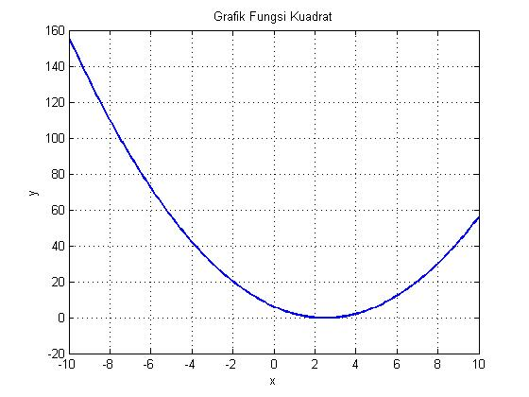

1. Plot fungsi kuadrat

Code :

x = -10:0.1:10;

y = x.^2 - 5*x + 6;

plot(x, y, 'LineWidth', 2);

title('Grafik Fungsi Kuadrat');

xlabel('x'); ylabel('y');

grid on;

1. Plot Fungsi Trigonometri (Sinus & Cosinus)

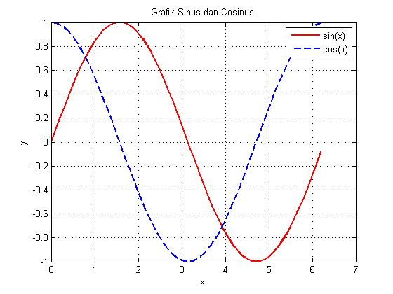Code:

x = 0:0.1:2*pi;

y1 = sin(x);

y2 = cos(x);

plot(x, y1, 'r', x, y2, 'b--', 'LineWidth', 2);

legend('sin(x)', 'cos(x)');

title('Grafik Sinus dan Cosinus');

xlabel('x'); ylabel('y');

grid on;

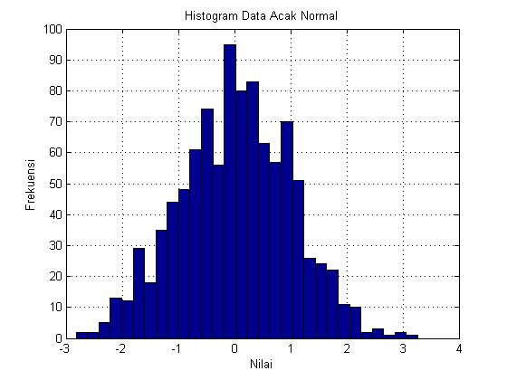

1. Histogram Data Acak Normal

Code:

data = randn(1,1000);

histogram(data, 30);

title('Histogram Data Acak Normal');

xlabel('Nilai'); ylabel('Frekuensi');

grid on;

1. Boxplot Data Random

Code:

data = [randn(100,1)+5; randn(100,1)+10];

group = [repmat({'Grup 1'},100,1); repmat({'Grup 2'},100,1)];

boxplot(data, group);

title('Boxplot Dua Grup Data');

grid on;

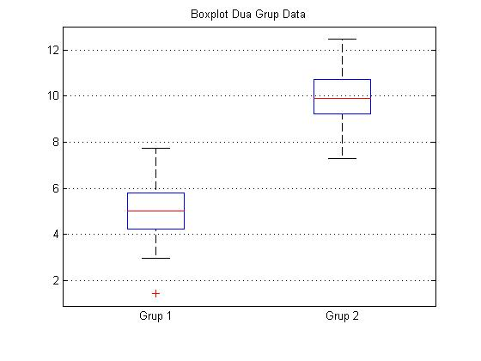

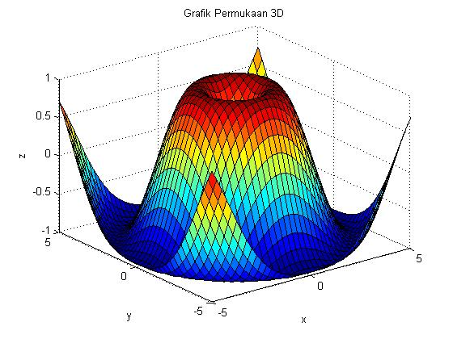

1. Plot 3D Permukaan (Surface Plot)

Code:

[x, y] = meshgrid(-5:0.25:5, -5:0.25:5);

z = sin(sqrt(x.^2 + y.^2));

surf(x, y, z);

title('Grafik Permukaan 3D');

xlabel('x'); ylabel('y'); zlabel('z');

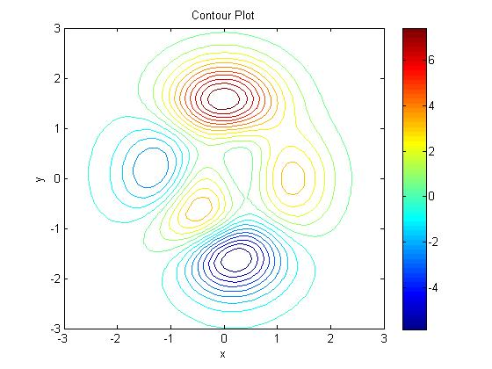

1. Contour Plot

Code:

[x, y] = meshgrid(-3:0.1:3, -3:0.1:3);

z = peaks(x, y);

contour(x, y, z, 20);

colorbar;

title('Contour Plot');

xlabel('x'); ylabel('y');

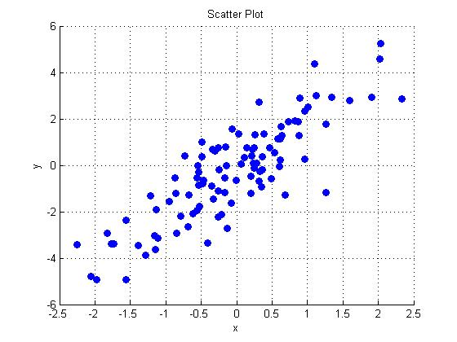

1. Scatter Plot (Sebaran Titik)

Code:

x = randn(100,1);

y = 2*x + randn(100,1);

scatter(x, y, 50, 'filled');

title('Scatter Plot');

xlabel('x'); ylabel('y');

grid on;

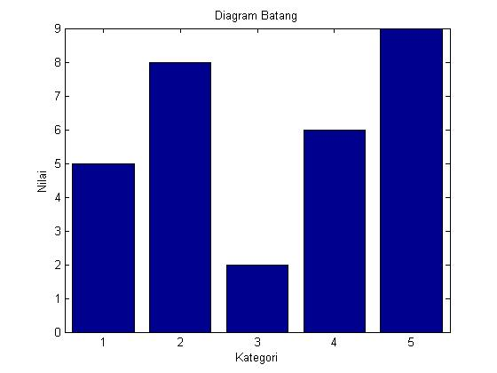

1. Bar Chart (Diagram Batang)

Code:

data = [5, 8, 2, 6, 9];

bar(data);

title('Diagram Batang');

xlabel('Kategori'); ylabel('Nilai');

xticklabels({'A','B','C','D','E'});

1. 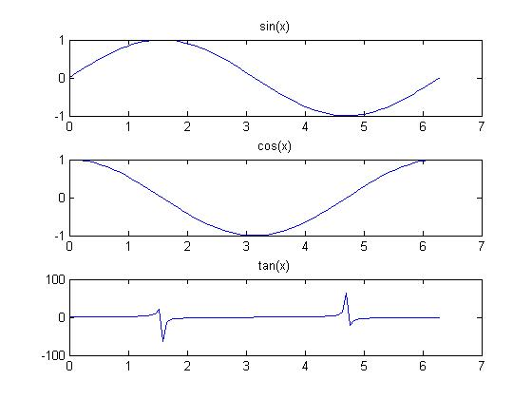Plot Banyak Fungsi dalam Subplot

Code:

x = linspace(0, 2*pi, 100);

y1 = sin(x);

y2 = cos(x);

y3 = tan(x);

subplot(3,1,1); plot(x, y1); title('sin(x)');

subplot(3,1,2); plot(x, y2); title('cos(x)');

subplot(3,1,3); plot(x, y3); title('tan(x)');

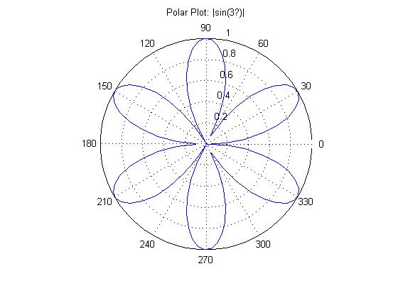

1. Polar Plot

Code:

theta = linspace(0, 2*pi, 100);

rho = abs(sin(3*theta));

polarplot(theta, rho, 'LineWidth', 2);

title('Polar Plot: |sin(3θ)|');

1. Heatmap (Peta Panas)

Code:

data = randi(100, 5, 5);

heatmap(data);

title('Heatmap (Peta Panas)');

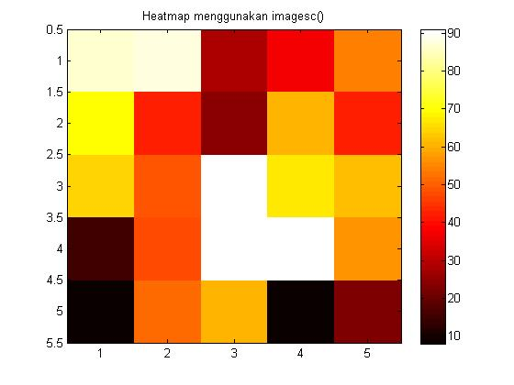

1. Stem Plot (Grafik Batang Diskrit)

Code:

x = 0:0.5:10;

y = sin(x);

stem(x, y, 'filled');

title('Stem Plot');

xlabel('x'); ylabel('sin(x)');

grid on;

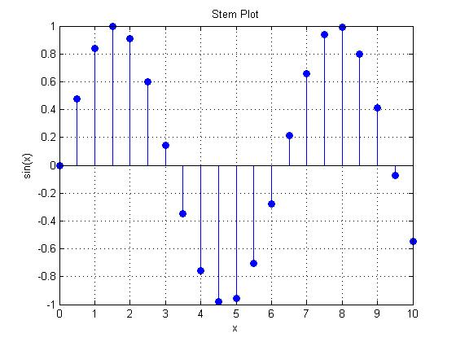

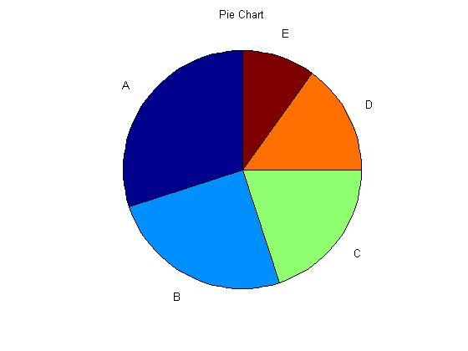

1. Pie Chart (Diagram Lingkaran)

Code:

data = [30, 25, 20, 15, 10];

labels = {'A','B','C','D','E'};

pie(data, labels);

title('Pie Chart');

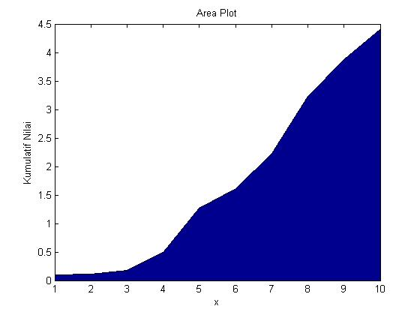

1. Area Plot (Diagram Luas)

Code:

x = 1:10;

y = cumsum(rand(1,10));

area(x, y);

title('Area Plot');

xlabel('x'); ylabel('Kumulatif Nilai');

1. Stairs Plot (Tangga Diskrit)

Code:

x = 0:10;

y = mod(x, 3);

stairs(x, y, 'LineWidth', 2);

title('Stairs Plot');

xlabel('x'); ylabel('mod(x,3)');

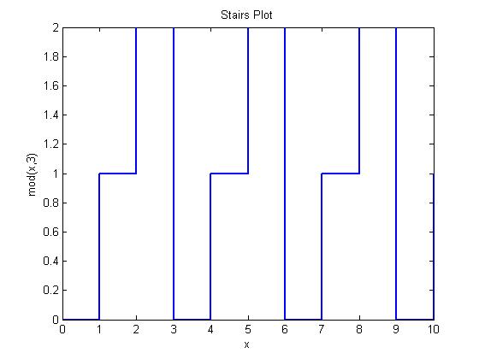

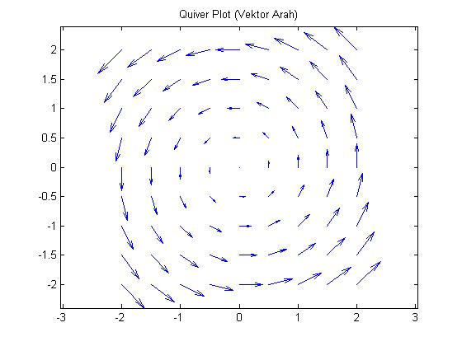

1. Quiver Plot (Vektor Panah 2D)

Code:

[x, y] = meshgrid(-2:0.5:2, -2:0.5:2);

u = -y;

v = x;

quiver(x, y, u, v);

title('Quiver Plot (Vektor Arah)');

axis equal;

1. 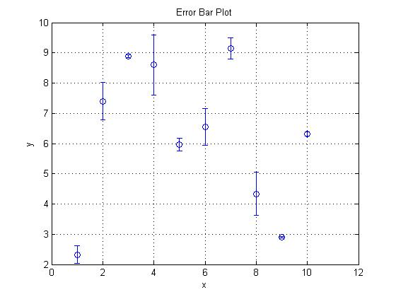Error Bar Plot

Code:

x = 1:10;

y = rand(1,10)*10;

e = rand(1,10);

errorbar(x, y, e, 'o');

title('Error Bar Plot');

xlabel('x'); ylabel('y');

grid on;

1. 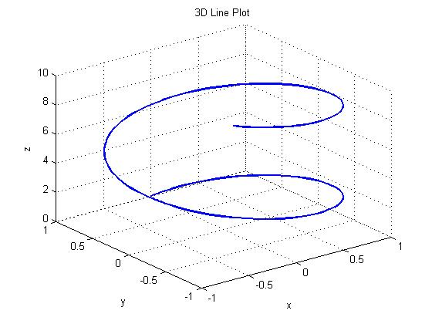3D Line Plot

Code:

t = 0:0.1:10;

x = sin(t);

y = cos(t);

z = t;

plot3(x, y, z, 'LineWidth', 2);

title('3D Line Plot');

xlabel('x'); ylabel('y'); zlabel('z');

grid on;

1. 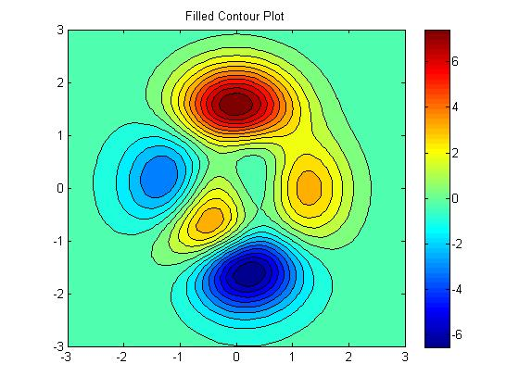Filled Contour Plot

Code:

[x, y] = meshgrid(-3:0.1:3, -3:0.1:3);

z = peaks(x, y);

contourf(x, y, z, 20);

colorbar;

title('Filled Contour Plot');

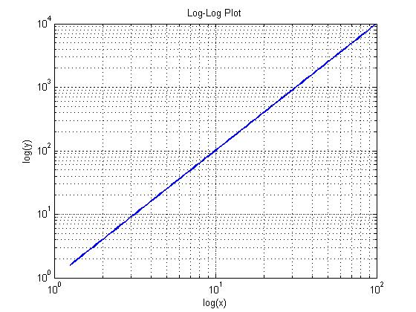

1. Log-Log Plot

Code:

x = logspace(0.1, 2, 100);

y = x.^2;

loglog(x, y, 'LineWidth', 2);

title('Log-Log Plot');

xlabel('log(x)'); ylabel('log(y)');

grid on;